**HTML AND CSS ASSIGNMENT**

Submitted by:Name : UDITA KALRA Roll No. : 2K23CSUN01235

# Department : B.Tech AIML-1A

Ques 1: What is the CSS Box Model, and how does it affect the layout of elements on a webpage?

Ans: A box in CSS consists of a content area, which is where any text, images, or other HTML elements are displayed. This is optionally surrounded by padding, a border, and a margin, on one or more sides. The box model describes how these elements work together to create a box as displayed by CSS. The CSS box model module defines the rectangular boxes, including their content, padding, border and margin, that are generated for elements and laid out according to the visual formatting model.

The CSS Box Model affects the layout of elements on a webpage in the following ways:

1. Sizing: The size of an element can be adjusted by changing its content, padding, border or margin properties. These properties determine the space occupied in a page.
2. Spacing: The padding and margin properties control the spacing between the element's content and its surrounding elements. Padding creates space within the element, while margin creates space around the element, affecting its position in relation to other elements.
3. Layout and positioning: The Box Model plays a crucial role in determining how elements are positioned within the page layout. Margins can be used to push elements away from each other or bring them closer together, and the combination of content, padding, and border affects the element's size and positioning.

Exercise: Provide a simple HTML structure with a few elements and ask the students to apply CSS properties to manipulate the box model, such as margin, padding, and border.

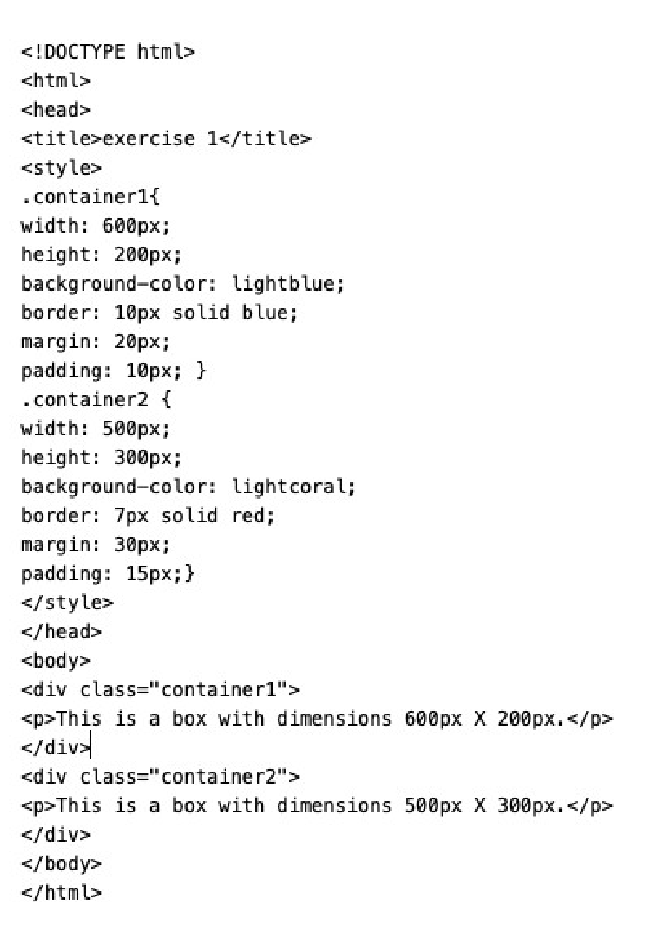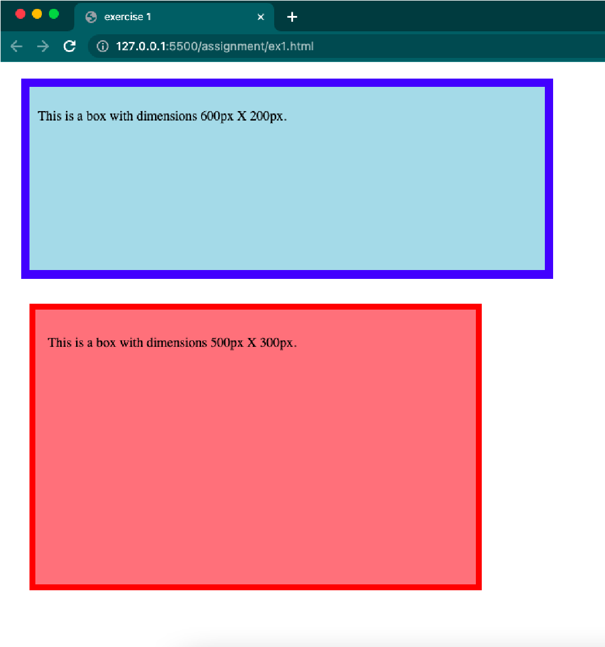

Ques 2: Explain the concept of CSS specificity. How is it determined, and why is it important in styling web pages?

Ans: CSS specificity is a concept that determines how conflicting and overlapping CSS rules are applied in HTML webpage. It defines which styles take precedence when multiple CSS rules target the same element, allowing developers to control the appearance of web pages effectively.

Specificity is an algorithm that calculates the weight that is applied to a given CSS declaration. The weight is determined by the number of selectors of each weight category in the selector matching the element.If there are two or more declarations providing different property values for the same element, the declaration value in the style block having the matching selector with the greatest algorithmic weight gets applied. The specificity algorithm is basically a three-column value of three categories or weights - ID, CLASS, and TYPE - corresponding to the three types of selectors.

To calculate specificity, assign a specific weight to each of these factors. For example:

* Inline styles have a specificity of 1,0,0,0.
* ID selectors have a specificity of 0,1,0,0.
* Class and attribute selectors have a specificity of 0,0,1,0.
* Tag selectors have a specificity of 0,0,0,1.

Then add up the specificity values for each selector in a CSS rule to compare them. The rule with the highest specificity is the one that takes precedence when there's a conflict.

Specificity is important in styling web pages because it helps resolve conflicts and maintain order in the styling process. It allows developers to target and style elements precisely, ensuring that the desired styles are applied without unintended side effects. Understanding specificity helps developers write more maintainable and predictable CSS, making it easier to design and maintain complex web layouts and designs.

Exercise: Present a set of HTML elements and CSS rules with varying levels of specificity, and ask students to predict the final styles applied to each element.

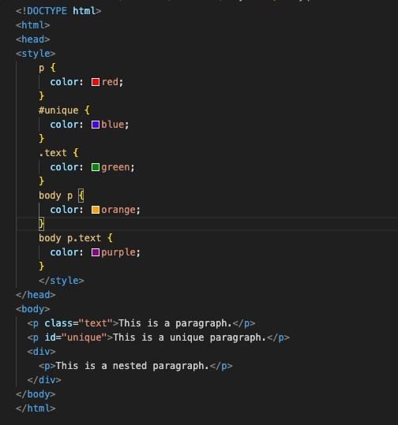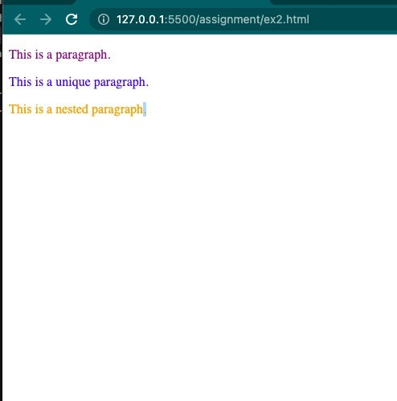

Ques 3: What are CSS Flexbox and CSS Grid? Describe when you would use each layout model, and provide an example of both.

Ans:

|  |  |
| --- | --- |
| CSS Flexbox | CSS Grid |
| Flexbox, or the Flexible Box Layout, is a onedimensional layout model that is best suited for arranging items in a single row or column. | CSS Grid is a two-dimensional layout model that allows you to create grid-based layouts with rows and columns. |
| It is excellent for creating flexible and dynamic layouts when dealing with elements in a linear or sequential manner. | It's ideal for designing complex, grid-based structures where items can be placed in both rows and columns. |
| Flexbox is particularly useful for building navigation menus, simple horizontal or vertical alignments, and controlling the distribution of space within a container. | CSS Grid provides precise control over the placement and alignment of elements within a grid, making it suitable for creating full-page layouts, multi-column designs, and responsive grid systems. |
| ex- navigation bar etc. | ex- product page |

Exercise: Ask students to create a webpage layout using CSS Flexbox and another using CSS Grid, and compare the differences in the resulting layouts.

CSS Flexbox-

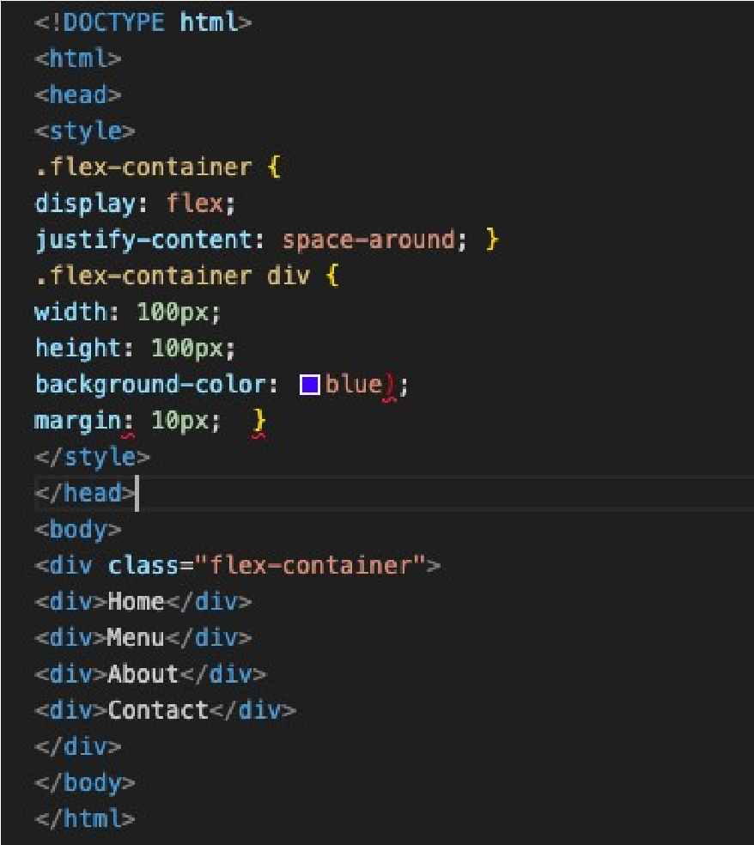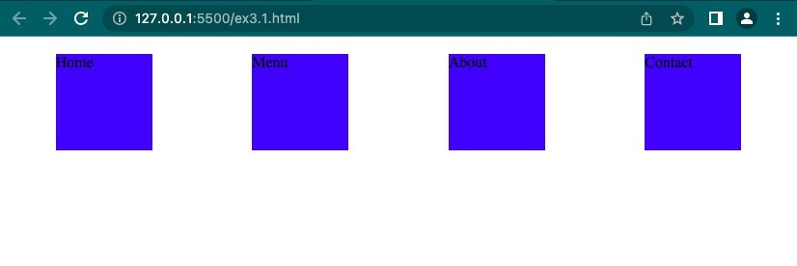

CSS Grid-

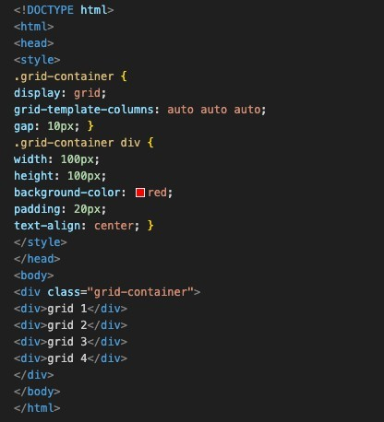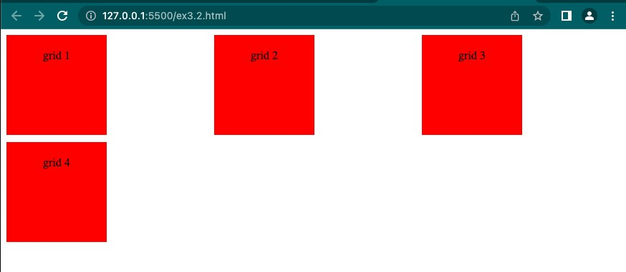

Ques 4: Describe the difference between `position: relative`, `position: absolute`, and `position: fixed` in CSS. When and how would you use each of these position values?

Ans:

1. ‘position: relative’:
   1. When ‘position: relative’ is applied to an element, it is positioned relative to its normal (static) position in the document flow.
   2. You can use the top, right, bottom, and left properties to offset the element from its normal position.
   3. Elements with ‘position: relative’ are still part of the document flow, which means they may affect the layout of surrounding elements. Other elements will be positioned as if the relatively positioned element still occupies its original space in the document flow.

Uses: To move an element slightly from its original position without affecting the layout of other elements. Creating simple CSS-based animations or transitions by changing the top, right, bottom, or left properties over time.

1. ‘position: absolute’:
   1. When you apply ‘position: absolute’ to an element, it is positioned relative to the nearest positioned ancestor (ancestor with position set to anything other than static) or the containing block (usually the nearest parent with position: relative, position: absolute, or position: fixed).
   2. Absolute positioning takes the element out of the normal document flow, meaning it won't affect the layout of other elements, and other elements won't affect it.

Uses: Creating overlays or pop-up dialogs that should appear at specific positions on the page.

Building complex layouts where precise control over the position of elements is needed.

Implementing elements like tooltips, dropdown menus, or modals.

1. ‘position: fixed’:
   1. When you apply position: fixed to an element, it is positioned relative to the viewport (the browser window) and remains in a fixed position, even when the page is scrolled.
   2. Fixed elements are taken out of the document flow and don't affect the layout of other elements.

Uses: Creating elements that should remain visible in the same position on the screen, such as navigation menus or headers, as the user scrolls through a long page. Implementing "sticky" elements that stay in a specific location within the viewport.

Exercise: Provide a webpage with elements that need to be positioned using the different values, and ask students to apply CSS to achieve the desired layout.

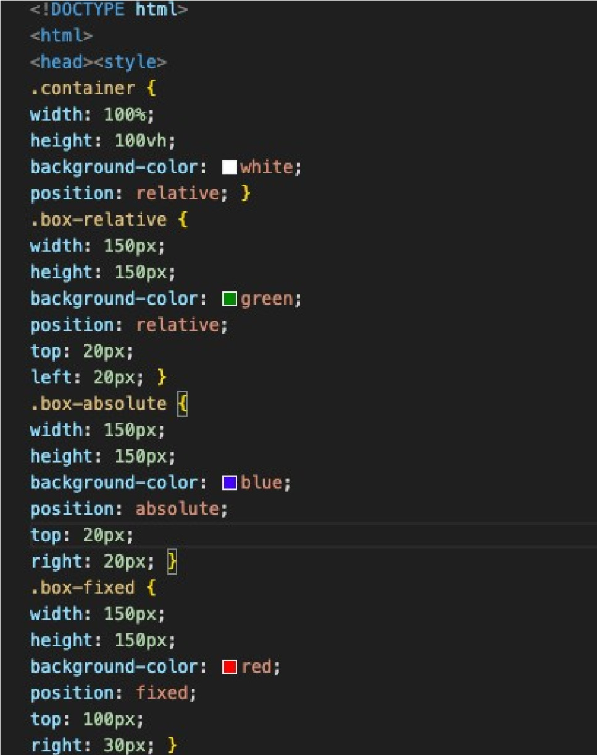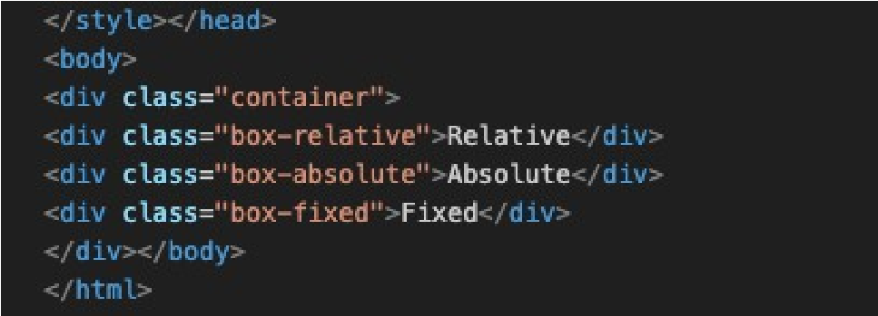

Ques 5: Explain the concept of CSS pseudo-elements like `::before` and `::after`. Provide an example where these pseudo-elements are used to enhance the design of a webpage.

Ans:

‘::before’ : This pseudo-element inserts content before the content of the selected element. It is often used to add decorative elements or textual content before an element.

‘::after’ : This pseudo-element inserts content after the content of the selected element. It is commonly used to add decorative elements, icons, or additional styling effects after an element. Exercise: Give students a webpage with specific design requirements and ask them to use pseudo- elements to achieve those enhancements.

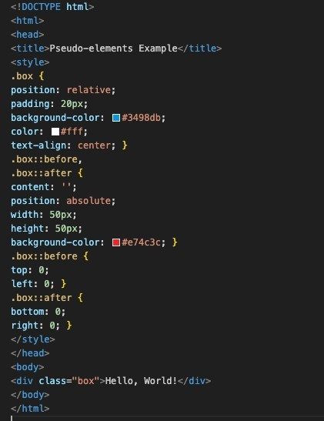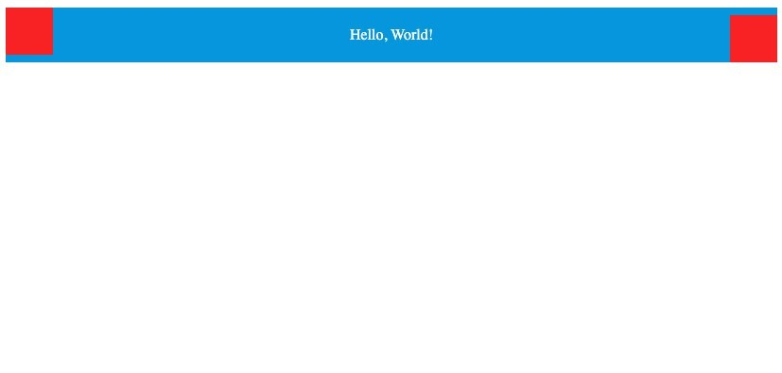

Ques 6: What is responsive web design, and how can media queries be used to create responsive layouts? Provide an example of a responsive webpage.

Ans: Responsive web design is an approach to designing and coding websites to provide an optimal viewing and interaction experience across a wide range of devices, from desktop monitors to mobile phones. The goal is to ensure that the website layout and content adapt fluidly to the dimensions of the device's screen.Media queries are a key component of responsive web design. They allow you to apply styles based on various characteristics of the device, such as its width, height, or even the device's orientation.

Exercise: Provide a basic webpage and ask students to create a responsive design using media queries to adapt the layout for different screen sizes.

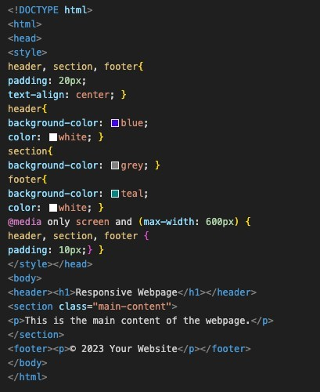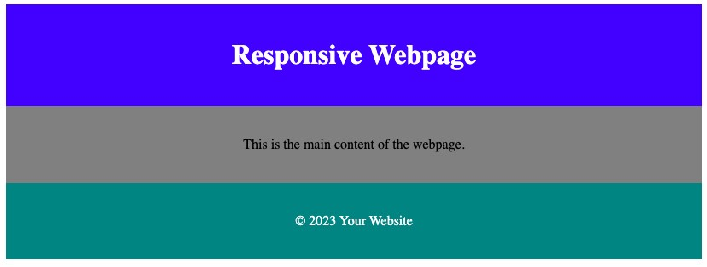

Ques 7: Discuss the importance of accessibility in web development. Explain ARIA roles and attributes, and provide an example of making a webpage more accessible.

Ans: Accessibility in web development is crucial as it ensures that websites and web applications can be used by people of all abilities and disabilities. It involves designing and developing websites in a way that makes them perceivable, operable, understandable, and robust for all users, including those with visual, auditory, motor, and cognitive disabilities.

ARIA (Accessible Rich Internet Applications) roles and attributes are part of the Web Content Accessibility Guidelines (WCAG) to enhance the accessibility of dynamic content and advanced user interface controls.

Roles: ARIA introduces roles that can be applied to elements to define their intended purpose. For example, role="button" can be added to a <div> to indicate that it functions as a button.

Attributes: ARIA attributes provide additional information about the state or property of an element. For instance, aria-hidden="true" can be used to hide an element from assistive technologies, and aria-labelledby can be used to associate an element with another element that serves as its label.

Exercise: Offer a webpage with accessibility issues, and ask students to improve its accessibility by adding ARIA roles and attributes.

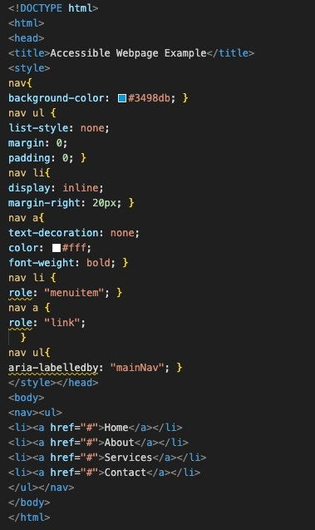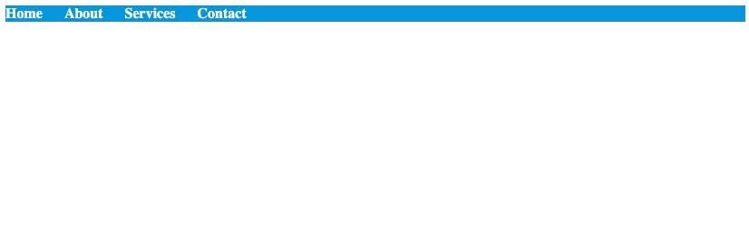

Ques 8: What is the purpose of the `<DOCTYPE>` declaration in HTML, and how does it affect the rendering of a webpage in different browsers?

Ans: The <!DOCTYPE> declaration in HTML (Hypertext Markup Language) is used to specify the version of HTML or XHTML that a web document is using. It serves as an instruction to web browsers and other software about how to interpret the markup of the document. The purpose of the <!DOCTYPE> declaration is to ensure that the web document is displayed correctly and consistently across different web browsers. Different web browsers have their own rendering engines, which interpret HTML and CSS to display web content. The presence of a correct and valid <!DOCTYPE> declaration ensures that the browser renders the webpage in standardscompliant mode, following the specified rules and standards for the declared version of HTML or XHTML. This helps maintain consistency and predictability in how the webpage is displayed across different browsers and devices.

Exercise: Ask students to create a simple HTML document and experiment with different `<DOCTYPE>` declarations to observe how they affect the rendering in various browsers.

